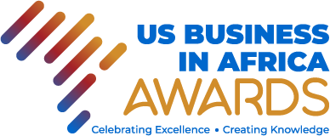

U.S. Business in Africa Awards (USBAA)
Celebrating Excellence. Creating Knowledge

USBAA 2022
Call for Submission of Entries

Entries for the inaugural USBAA hosted by the African Center for studying the United States (ACSUS) and its partners are now open. USBAA aims to celebrate and foster a culture of responsible and good corporate citizenship by U.S. businesses operating in Africa. This call initiates a process leading to the recognition and celebration of excelling U.S. multinational businesses (MNBs) and small and mid-sized businesses (SMBs). The awards ceremony will be held in October 2022 in Johannesburg, South Africa. The awards will recognize, and showcase ten excelling American businesses operating in all five regions of Africa.
Who is Eligible?
- Must be an American business operating in Africa.
- Must be registered in the U.S. and at least one African country
- Demonstrate investments and operations in Africa.

For both MNBS and SMBs the winning categories are as follows
- Platinum: overall winner
- Gold: first runner-up
- Silver: second runner-up
- Bronze: third runner-up
- Organising Committee’s special mention

To submit an entry fill in this form.
Closing Date 20 June 2022
For further detailed information, kindly access the concept note available here.
The judging criteria are also available here.
To contact us:
Email: acsus.research@wits.ac.za usbaa@wits.ac.za
Tel: +27 11 717

